How to Enrol in Little Splashers (Infant Swim)
Step 1: Visit the Website
Visit: https://envibe.hume.vic.gov.au/
Step 2: Log In
Create an account by clicking on LOG IN
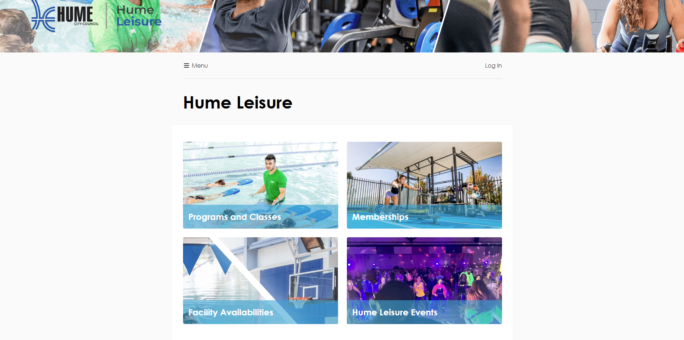
Step 3: Create an Account:
Select CREATE ACCOUNT
Enter parent/guardian date of birth and email address
Once details are entered this will generate an email to be sent to the address input. Follow the instructions on that email, this will involve setting a password that you will use to gain ongoing access to the portal.
Nb. If your do not receive this email, please contact our customer service teams and they will arrange for it to be resent or someone to assist you with a password.
Step 4: Access the Portal
After logging in, select Programs and Classes from the home page.
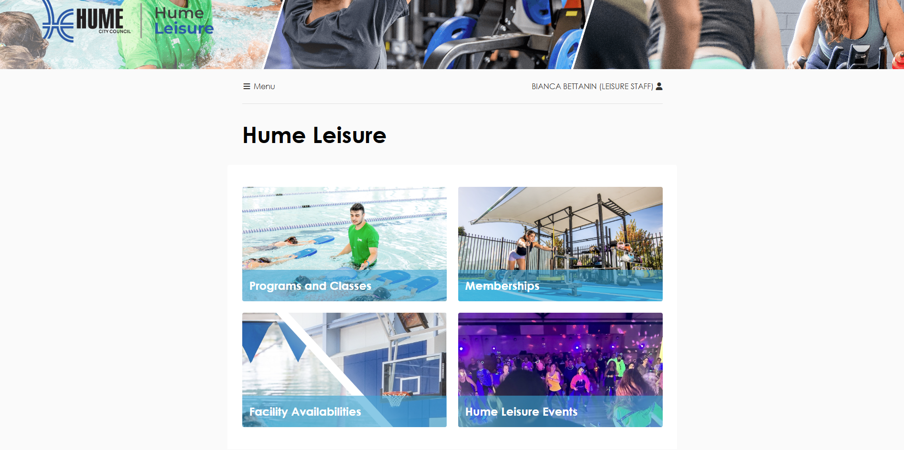
Step 5: Start a New Enrolment
From the Programs and Classes screen, select New Enrolment.
Step 6: Select Enrolment Details
Choose the following options:
- Location: Select the site you wish to attend
- Program: Little Splashers Swim Sessions
- Level: Infant Swim (Target age 3–6 months)
Click Continue to proceed.

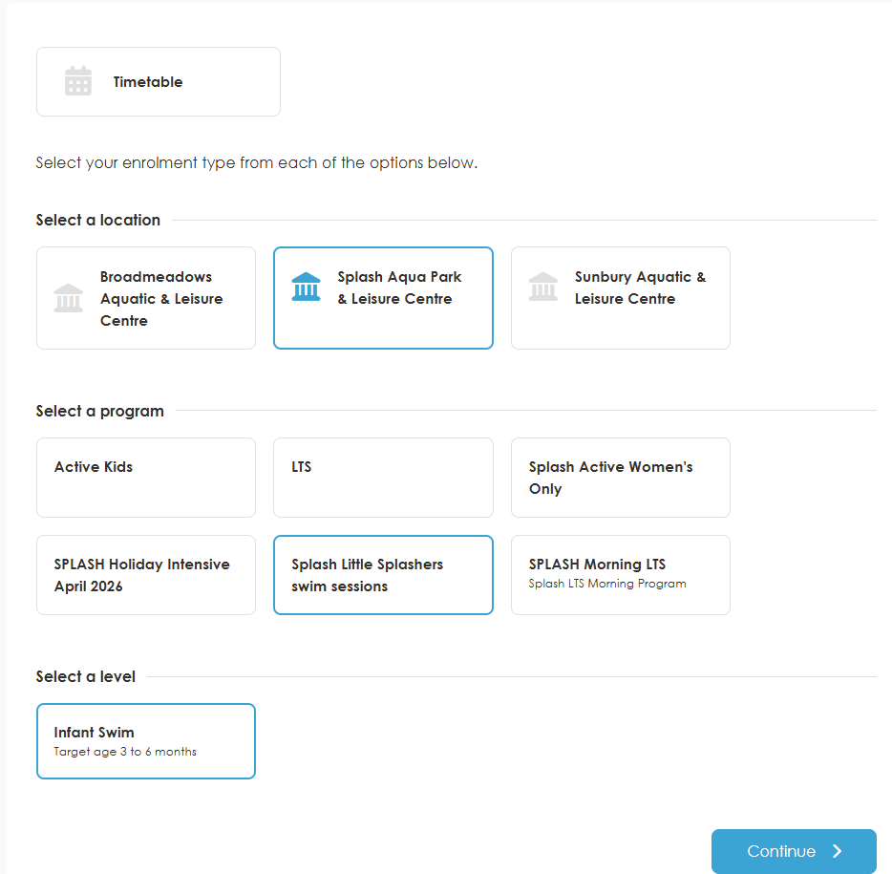

Step 7: Select a Class
Choose the class that suits you best.

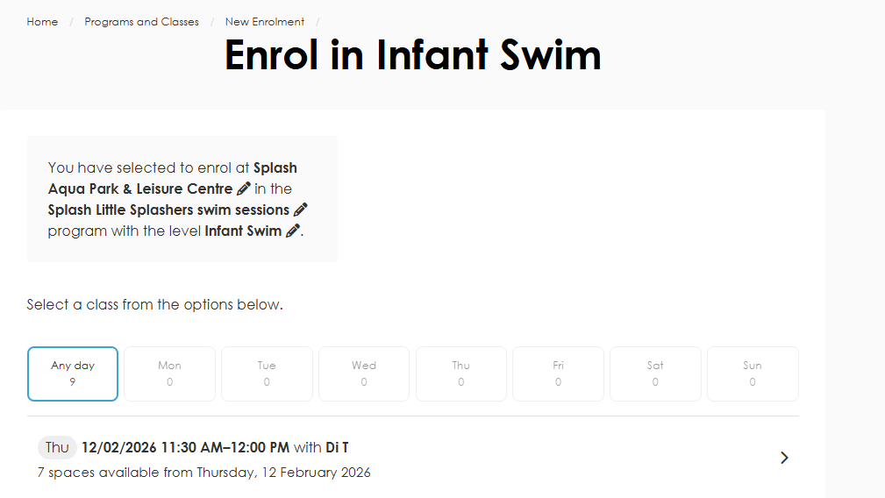

Step 8: Select a Start Date
Select your preferred start date, then click Continue.
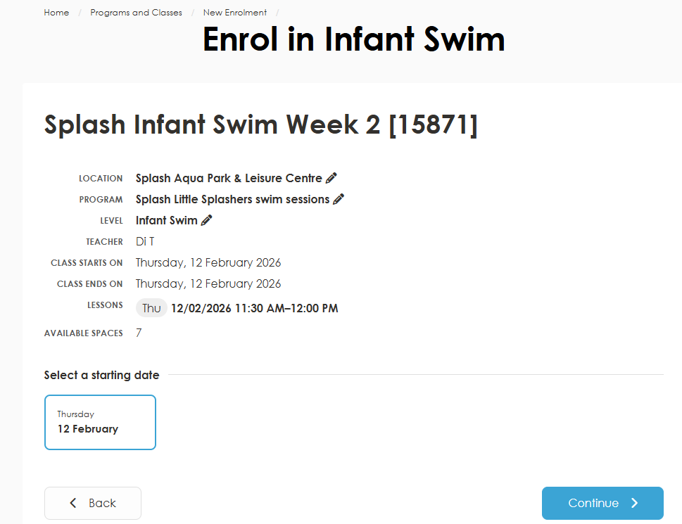
Step 9: Enrolment Options
If your child does not already have a profile with us:
- Select SOMEONE ELSE
- Click Continue
- Enter your child’s details and continue
Once completed, the child will be linked to your online account. You can switch between users by selecting Select User from the account page.
Note:
If you do not wish to link this person to your account, please cancel the enrolment, log out, and create a new account instead.
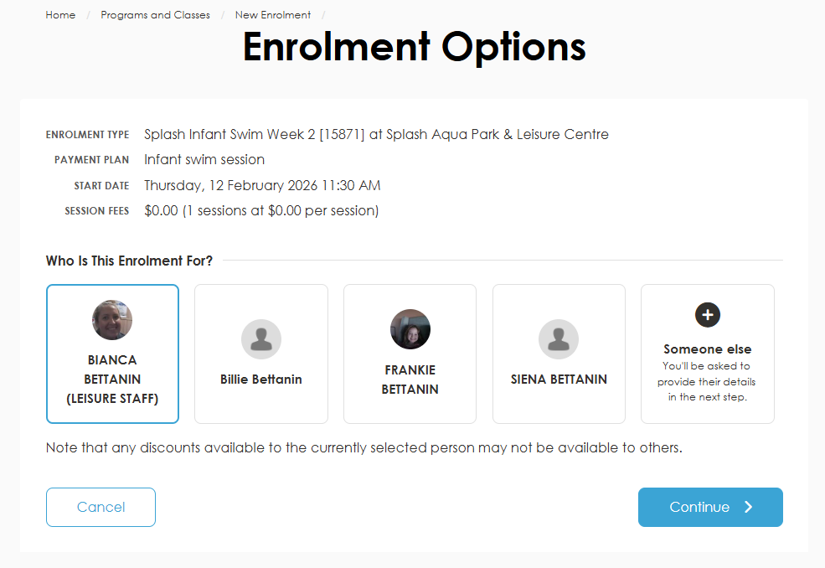

Step 10: Complete Enrolment
As this program is free, simply:
- Press Complete
- On the following screen, select Complete Purchase

